Module 8.2 Assignment
Kobe Alexander
5/2/2026
Bellevue University
CSD 325

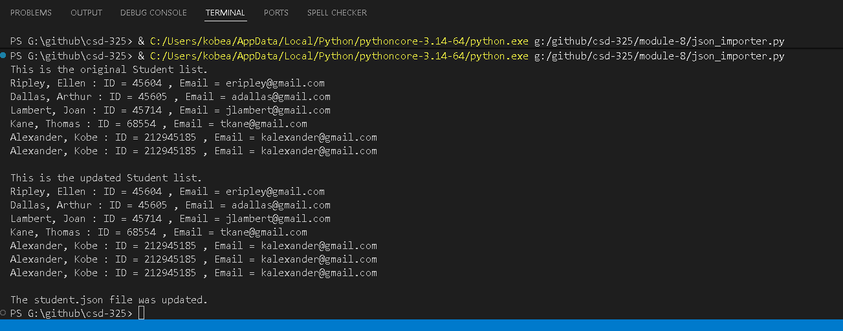
My wouldn’t prompt when it ran but would still save on the fly, but if I tried to close the file it would prompt me to save changes
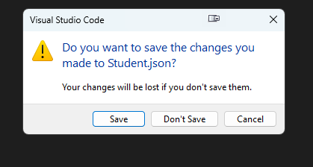
[
{
"F_Name": "Ellen",
"L_Name": "Ripley",
"Student_ID": 45604,
"Email": "eripley@gmail.com"
},
{
"F_Name": "Arthur",
"L_Name": "Dallas",
"Student_ID": 45605,
"Email": "adallas@gmail.com"
},
{
"F_Name": "Joan",
"L_Name": "Lambert",
"Student_ID": 45714,
"Email": "jlambert@gmail.com"
},
{
"F_Name": "Thomas",
"L_Name": "Kane",
"Student_ID": 68554,
"Email": "tkane@gmail.com"
},
{
"F_Name": "Kobe",
"L_Name": "Alexander",
"Student_ID": 212945185,
"Email": "kalexander@gmail.com"
}
]

